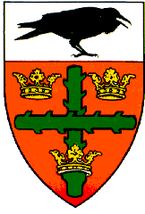
Colchester Rugby Football Club
Clubhouse: Mill Road Colchester CO4 5JF: Tel: 01206 851610

ANNUAL GENERAL MEETING

Date and time of meeting: Thursday 28th April 2016 at 7:30

AGENDA:

Welcome: Given by A.Wadling (President)

- Apologies for absence:

- Minutes of the previous AGM

- Annual Officers' Reports:
Senior Rugby Chairperson - Andy Cryne
Youth Chairperson - Ross Cowie
Minis' Chairperson - Catherine Miller
Treasurer - Norman Gould
Chairman - Karl O'Brien
President - Andy Wadling

- Election of Officers:

- Annual Subscriptions for 2016 - 2017

- Nominations for Life Membership

- Any Other Business:

- Date & Time of next AGM: 27th April 2017 at 7:30 for 8:00 p.m.

